**RAJSHAHI UNIVERSITY OF ENGINEERING AND TECHNOLOGY**

**Course No:** CSE 3110

**Course Title:** Sessional Based on CSE 3109

**Problem No:** 06

**Problem Name:** Write a program to sort an array in descending order and display numbers, capital letters, small letters in descending order on different line.

**Submitted To:**

Sadia Zaman Mishu

Assistant Professor

Computer Science and Engineering

Rajshahi University of Engineering and Technology

**Submitted By:**

Name : Md. Fakhrul Islam

Roll: 1803071

Session: 2018-19

Department : Computer Science and Engineering

Rajshahi University of Engineering and Technology

**Problem No:** 06

**Problem Name:** Write a program to sort an array in descending order and display numbers, capital letters, small letters in descending order on different line.

**Description:**

A one-dimensional array is an ordered list of elements, all of the same type. Register indirect addressing mode is one of the additional addressing modes in array. The register is BX, SI, DI or BP. For BX, SI, DI, DS has the segment number. And for BP, SS has the segment number. In this problem, SI register is used for addressing. To sort the array, selection sort is used. Procedures work just like functions in higher level programming language. One of the procedures is the main procedure, and it contains the entry point to the program. Call instruction is used to call a procedure. Ret instruction is used for returning in main procedure. In this program, select procedure is created for selection sort. Besides, to display the result, output procedure is used.

**CODE:**

|  |  |
| --- | --- |
| .MODEL SMALL  .STACK 100H  .DATA  A DB 50 DUP('?')  .CODE  MAIN PROC  MOV AX, @DATA  MOV DS,AX  LEA SI,A  MOV BX,0  INPUT:  MOV AH,1  INT 21H  MOV A[SI],AL  INC SI  INC BX  CALL SELECT  MOV AH,2  MOV DL,0AH  INT 21H  MOV DL,0DH  INT 21H  CALL OUTPUT  MOV AH,2  MOV DL,0AH  INT 21H  MOV DL,0DH  INT 21H  JMP INPUT  MOV AH,4CH  INT 21H  MAIN ENDP  SELECT PROC  PUSH BX  PUSH CX  PUSH DX  PUSH SI  DEC BX  JE END_SORT  LEA SI,A  JNL NEXT  MOV DI,SI  MOV AL,[DI]  NEXT:  LOOP FIND_BIG  CALL SWAP  DEC BX  JNE SORT_LOOP  END_SORT:  POP SI  POP DX  POP CX  POP BX  RET  SELECT ENDP  SWAP PROC  PUSH AX  MOV AL,[SI]  XCHG AL,[DI]  MOV [SI],AL  POP AX  RET  SWAP ENDP | MOV DX,SI  SORT_LOOP:  MOV SI,DX  MOV CX,BX  MOV DI,SI  MOV AL,[DI]  FIND_BIG:  INC SI  CMP [SI],AL  OUTPUT PROC  LEA SI,A  MOV CX,BX  PRINT:  MOV AH,2  MOV DL,[SI]  CMP DL,5BH  JL PRI  INT 21H  ADD SI,1  DEC CX  CMP CX,0  JE EXIT  CMP CX,0  JG PRINT  PRI:  MOV AH,2  MOV DL,0AH  INT 21H  MOV DL,0DH  INT 21H  PRINT1:  MOV AH,2  MOV DL,[SI]  CMP DL,3AH  JL PRI1  INT 21H  ADD SI,1  DEC CX  CMP CX,0  JE EXIT  CMP CX,0  JG PRINT1  PRI1:  MOV AH,2  MOV DL,0AH  INT 21H  MOV DL,0DH  INT 21H  PRINT2:  MOV AH,2  MOV DL,[SI]  INT 21H  ADD SI,1  DEC CX  CMP CX,0  JE EXIT  CMP CX,0  JG PRINT2  EXIT:  RET  OUTPUT ENDP  END MAIN |

**OUTPUT:**

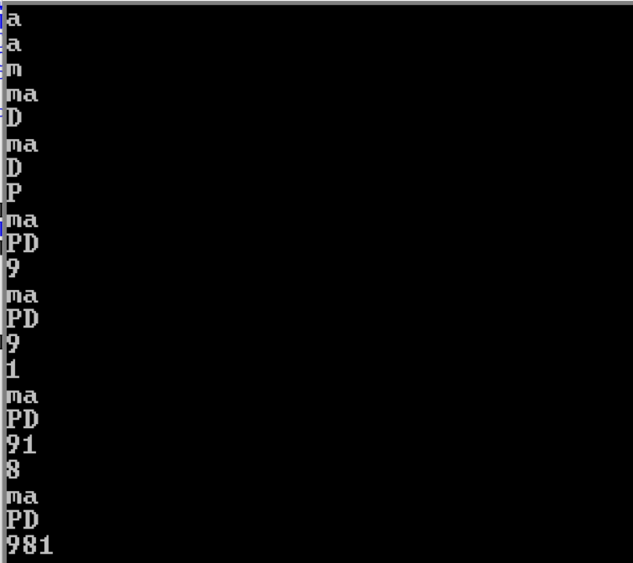

**Conclusion:**

In this program, selection sort is used for sorting the array in descending order. There are decimal numbers, capital letters, small letters. So, the array is sorted on the base of ascii codes. Small will be first, then capital letter and decimal number. The performance of the program will be faster, if faster sorting algorithm is used like quick sort merge sort etc.